Semley Village Hall

Information for Hirers – Please read carefully

Semley Village Hall (the Hall) is for the use and enjoyment of the whole community. It is managed by a committee of volunteers who hope that you will enjoy your use of the hall.

Opening and Closing the Hall is the responsibility of the Hirer. The keys for the hall and the audio-visual equipment are available from Mrs. Aban McAndrew and, after locking up, must be returned immediately. Telephone 07846 544211 in case of difficulty.

Health and Safety is a major priority for Semley Village Hall. The Safety Policy is located in the Kitchen on the shelf so marked. Hirers are responsible health and safety, health (including reducing the risk of COVID) and hygiene, and fire safety and should read the Hirers Responsibilities sections thoroughly.

- Hirers must provide the Bookings Secretary with details of proposed use when booking.

- The Village Hall has a “NO SMOKING” policy; no smoking, naked flames or flammable substances are allowed in the building or play area. Smoking is allowed in the designated area by the car park.

- Decorations or notices must not be fixed near heaters or light fittings. Do not use drawing pins; use “Blu-Tack”. Heavy equipment must be placed on mats to protect the hall floor from damage.

- In the event of a serious incident, accident, or fire, immediately call the emergency services on 999 and then a member of the Village Hall committee (see below) using the hall phone. The phone number is 01747 830617.

- In the event of an accident, a First Aid Box is in the kitchen. Any accident must be recorded in the Accident Book (located in marked Drawer) and reported to the Management Committee.

- The nearest Defibrillator is at Church Farm Dairy. Turn right out of the car park towards Church Green. Church farm is about half a mile away, just past the Benett Arms on the left. A Minor Injuries Unit is located at Shaftesbury Hospital, but not 24 hours / day.

- In the event of fire, the person in charge will instruct all persons to leave the hall using the nearest exit, move to the Fire Assembly Point and not re-enter the Hall. Upon arrival of the Fire Brigade, the person in charge will advise the Officer in Charge if all are safe and accounted for.
  - The three exits are the main entrance, the door to the Play Area and the emergency exit located at the east end of the main hall.
  - The Hirer is responsible for instructing Village Hall occupants on the location of the exits
  - The Fire Assembly Point is to the front of the Village Hall
  - Fires should only be extinguished if it is safe to do so. Locations of three fire extinguishers and a fire blanket as shown overleaf. Instructions for use are on the equipment.

- If a person exhibits symptoms of COVID-19 at the hall, a COVID-19 Response Box and instructions for the COVID-19 Responder, are in the kitchen. The person must go home, the hall vacated, and the Bookings Secretary informed.

Heating is provided by electrical heaters located on the walls of the hall and toilets. They are controlled by main switches in the lobby. The hall heaters are controlled by a thermostat and timer located in the hall. Please only use the heaters as necessary to minimise heating costs.

Lighting is provided throughout the Village Hall. External Security Lights at the front of the hall are automatically activated at dusk. Lighting in the toilets is automatically switched on by infrared sensors.

Any electrical equipment used by Hirers in the Village Hall must be PAT tested or certified by the Hirers to be in in good condition and used in a safe manner. Cables shall be positioned and protected so they do not cause a trip hazard or be subject to mechanical damage. The Fuse Box is located on the wall, in the lobby, opposite the main entrance.

Drinking water is provided in the kitchen. Hot and cold water is provided in the kitchen and toilets. The external stop cock is located outside to the right of the main entrance door. The long handle stop cock key is located in the store room.

A cooker, fridge, water heater, glassware, cutlery and crockery are provided in the kitchen.
- The Hirer is responsible for the safe preparation and serving of any food and/or beverages and for any licences required to do so.
- Glassware, cutlery and crockery must be washed thoroughly before being put away.
- If used, do not leave the cooker unattended. The Water Heater must remain on.

Tables are located in the storage area. After use, they should be cleaned, folded, and stacked away:
- The 6ft folding tables should be stacked in the storeroom and secured using the safety cord; the 3ft folding tables should be stacked under the shelving in the hall.
- Stacking chairs should by the emergency exit door in the hall. Folding chairs should be stored under the bench seats in the hall.

Window blinds should be stowed after use to permit proper ventilation of the hall.

WiFi can be accessed via BT_Guest_Wi-Fi and accepting BT terms and conditions of use,

The hall has the following licences:
- Premises Licence allowing Hirers to sell alcohol, play recorded music and perform live music for profit between the hours of 07.00 and 00.00. Hirers must abide by the conditions of the licence that is on display and copy held in the kitchen including:
  - Ensuring that alcohol is not served to intoxicated customers, and there is no irresponsible promotion of the sale of alcohol including activities that encourage the consumption of alcohol.
  - Adopt the “Challenge 25” Age Verification Policy to ensure no person under the age of 18 is served alcohol.
  - Only sell alcohol from securely closed containers, or for beer / cider in 1/2 pint measures, for spirits in 25ml or 35ml measures, and still wine in 125ml measures.
  - Record refusals of service in the Incident Book located in the kitchen.
  - Conduct regular noise checks outside the premises and take action to reduce excess noise.
- Premises Licence allowing Hirers to screen films for profit during the hours of 10.00 and 23.00. Hirers must abide the terms and conditions of the licence including ensuring children attending screenings of films abide by age classification ratings and required copyright licenses are obtained.
- TV license allowing Hirers to watch programmes being shown on TV or live on an online TV service, or downloading or watching BBC programmes on demand, including catch up TV, and BBC iPlayer.
- Performing Rights Society / Phonographic Performance Ltd. (PRS/PPL) licenses allowing Hirers to play music covered by the licenses. If the hall is being used for commercial “for profit” purposes, the Hirer must have its own PPL license.

Hirers using the audio-visual equipment should refer to “Operation of Audio-Visual Equipment” document for guidance.

Cleanliness is a very high priority for the Village Hall Committee and the Hall is cleaned on a regular basis. However, Hirers must ensure that:
- all table tops, shelf surface, chairs and frequently touched areas are wiped clean after use,
- the hall, kitchen, and lobby floors are swept after use,
- the kitchen and toilets are kept clean, tidy and odour free, and
- all litter and waste is removed from the hall and disposed of correctly.

If a Hirer intends to clean the Hall in the morning after being hired the previous evening, then the Hirer shall hire the Hall for that period as well and ensure that all cleaning is completed before 12.00 Noon.

The Village Hall Management Committee reserves the right to require a Cash Deposit from the Hirer before the Hall is hired, to cover additional cleaning, damage, and breakages. The deposit will be returned to the Hirer after the Hall has successfully passed inspection for cleanliness, damage, and breakages, no later than one week after the date of inspection.

The main Car Park is to the left of the Hall. Cars should be parked “tail in” to the railway embankment. The Lay-By in front of the Hall accommodates a small number of cars if parked sensibly.

The road outside the Village Hall is a public road and must not be obstructed. Cars can be parked on the Village Hall side of the public road towards the A350. Cars must not be parked on the road or common opposite the Village Hall

Hirers must be considerate to neighbours; keep noise levels to an acceptable level and leave the Hall quietly after events, especially at night ensuring that car doors are closed quietly and no loud talk.

Faults and damage should be reported as soon as they are found to a member of the Village Hall Management Committee (phone numbers below) so they may be rectified as quickly as possible. Do not attempt to use or repair faulty Village Hall equipment.

Comments, observations, photographs & suggestions about the hiring of the Village Hall are welcomed by the Village Hall Committee and can be sent to semleyvillagehall@gmail.com or posted on our Facebook page or internal notice board. https://www.facebook.com/semleyvillagehall/?ref=aymt_homepage_panel

On vacating the hall, the hirer is responsible for ensuring:
- all heating, water heater, and audio-visual equipment is turned off,
- all windows and doors are secure,
- the gates are closed, and
- the keys are returned to the Bookings Secretary at 123 Church Green, Semley, SP7 9AS.

Contact Numbers of Management Committee

Mrs. Aban McAndrew (Primary Contact) 07846 544211
Mr. A. Duthie, Chairman 01747 830396 or 07889 096749
Mr. D. Perry, Treasurer 01747 850059 or 07748 626748
Mrs. A. Becker 01747 830214 or 07999 404851
Mr. A. Roger 07484 349701

Semley Village Hall Management Committee
August 1st 2023

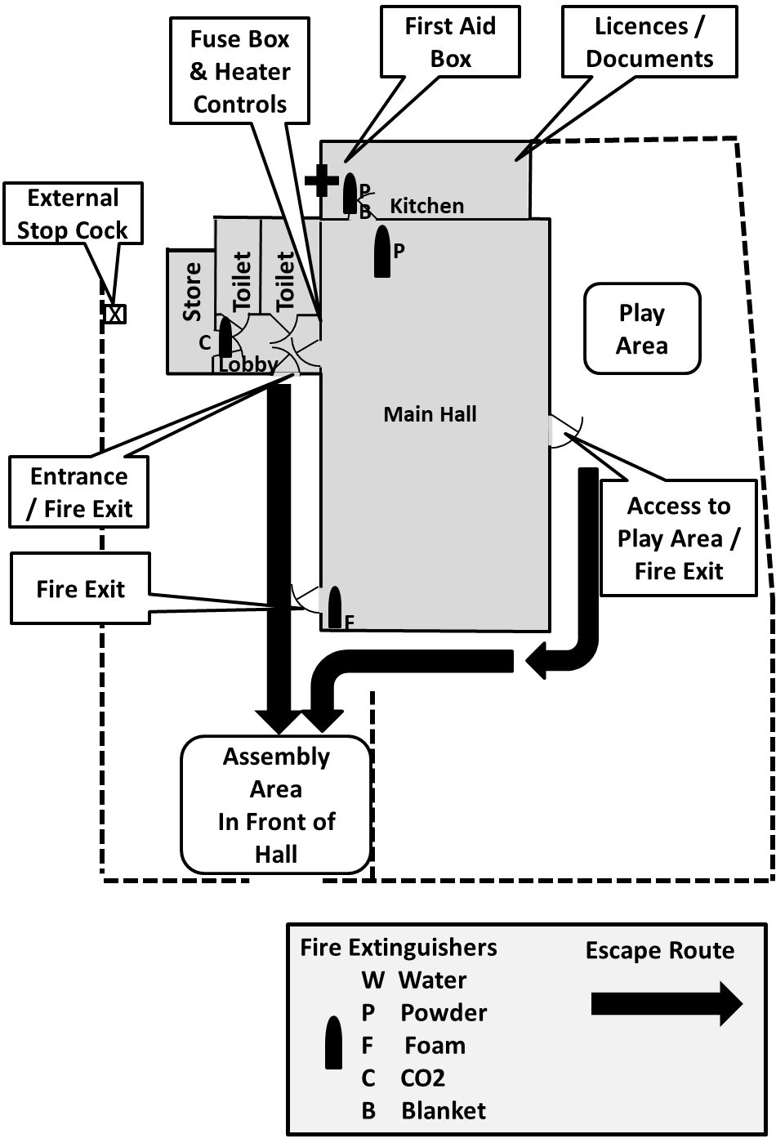

Location of Fire Equipment, Fire Exits, Escape Routes, Assembly Point, First Aid, Heater Controls, Fuse Box, Water Stop Cock, Licences and Documents

